

# COLLEGE OF TECHNOLOGY

**SILVER OAK COLLEGE OF ENGINEERING & TECHNOLOGY**

**DEPARTMENT OF COMPUTER ENGINEERING (CSE)**

A Report on

# Collegify (College Buddy Finder)

Under Subject of

# INNOVATION AND DESIGN THINKING - II

Semester - IV

***Submitted by***

CHAURASIYA KAVYA SHRIRAM

PANDEY SAURABH TIRTHRAJ

VASAVA GOPALBHAI VISHWASBHAI

CHAUDHARY MOHITKUMAR RUPARAM

**Ms. Vishwa Patel Mr. Mayuresh Kulkarni**

Internal Guide Head of the Department

**Silver Oak College of Engineering & Technology**

Department of Computer Engineering (CSE)

**CERTIFICATE**

This is to certify that the project entitled “Collegify” has been carried out by

**“**Chaurasiya Kavya”**, “**Pandey Saurabh **“**Vasava Gopal”, **“**Chaudhary Mohit”

under my guidance in fulfillment of the Innovation and Design Thinking-II (1010043292) Subject of Bachelor of Engineering in **Computer Engineering (CSE)** – 4th Semester of Silver Oak University, Ahmedabad during the academic year 2024- 2025.

Ms. Vishwa PatelMr. Mayuresh Kulkarni

Internal Guide Head of the Department

## ACKNOWLEDGEMENT

We are heartily thankful to our supervisor, Ms. Vishwa Patel, whose encouragement, supervision and support from the preliminary to the concluding level enabled me to develop an understanding of the subject. At the end, we offer my regards and blessings to all of those who supported us in any respect during the completion of the project and to our college for providing a resources and materials.

We would like to extend my gratitude to Mr. Mayuresh Kulkarni head of Information Technology Engineering Department, Silver Oak college of Engineering and Technology, Ahmedabad, for his continuous encouragement and motivation.

Last but not the least we would like to mention here that we are greatly indebted to each and everybody who has been associated with our project at any stage but whose name does not find a place in this acknowledgement.

**Yours Sincerely**

CHAURASIYA KAVYA SHRIRAM

PANDEY SAURABH TIRTHRAJ

VASAVA GOPALBHAI VISHWASBHAI

CHAUDHARY MOHITKUMAR RUPARAM

**ABSTRACT**

In today’s college life, connecting with the right people is very important for learning, working on projects, and making new friends. *Collegify* is a web-based platform made to help students easily find and connect with others who share the same interests, subjects, or goals. Whether it’s for study groups, teamwork, or social activities, this platform makes it simple.

The system uses smart AI technology to match students based on their courses, skills, and availability. It also includes features like real-time chat and smart suggestions to help students communicate and work together better.

The main aim of *Collegify* is to reduce loneliness, improve teamwork, and build a friendly and helpful college environment. This report explains how the idea was developed, how the system works, and how it fits with the subject of *Innovation and Design Thinking*. It also looks at how this platform can grow in the future to help even more students.

The platform also offers real-time messaging, collaboration tools, and event creation features, making it easy for students to organize study groups and collaborate on projects. With a focus on security and privacy, it allows students to connect in a safe and controlled environment. By promoting peer learning, efficient teamwork, and academic networking, College Buddy Finder aims to enhance the overall college experience.

The platform serves as an essential tool for students, helping them find study partners, expand their academic networks, and achieve better learning outcomes. With its user-friendly interface and robust features, College Buddy Finder is poised to be an invaluable resource for today’s college students.

## TABLE OF CONTENT

|  |  |  |
| --- | --- | --- |
| **Chapter No.** | **Title** | **Page No.** |
|  | **ACKNOWLEDGEMENT** | **i** |
|  | **ABSTRACT** | **ii** |
|  | **LIST OF FIGURES** | **iii** |
|  | **LIST OF TABLES** | **iv** |
| **1** | **INTRODUCTION** | **1** |
|  | **Project Summary** | **2** |
|  | **Purpose** | **3** |
|  | **Scope** |  |
|  | **Technical and Literature Review** |  |
| **2** | **SYSTEM REQUIREMENT STUDY** |  |
|  | **User Characteristics** |  |

**Hardware and Software Characteristics**

**Hardware Requirements Software Requirements**

1. **SYSTEM ANALYSIS**

**Study of Current System**

**Problems in Existing Systems Requirement of New System Functional Requirement**

**Non-functional Requirement**

**Feasibility Study**

**Main Modules of New System**

1. **SYSTEM DESIGN**

**Flow charts**

**Samples of Forms, Screen Shots**

1. **LIMITATION AND FUTURE ENHANCEMENT**
2. **TIMELINE CHART**
3. **CONCLUSION REFERENCE**

**Chapter 1: INTRODUCTION**

* 1. Project Summary

Collegify is an AI-based web platform that helps students find compatible buddies for academic and extracurricular collaboration. It addresses the widespread issue of students struggling to form study groups or find like-minded peers. By leveraging AI matching algorithms and user profiles, the platform enables meaningful connections based on course subjects, skills, and interests.

* 1. Purpose

The main purpose of this project is to develop an innovative solution to improve student connectivity in colleges. Collegify provides a digital platform where students can build academic and social networks with ease, enhancing collaboration and engagement within the campus environment.

* 1. Scope

This platform is intended for use by college students and educational institutions. It enables peer matching, chat communication, event updates, and availability tracking. The system supports academic success, mental well-being, and social integration. The project will focus on frontend design, backend matching logic, and real-time communication modules.

* 1. Technical and Literature Review

Our review focused on similar platforms and technologies used for social and academic networking. Existing apps like LinkedIn and Facebook offer broad networking, but none are tailored for internal campus collaboration. Research papers such as “Investigating the Potential of AI-Based Social Matching Systems” highlight the effectiveness of AI in improving student interaction. Related patents like US7069308B2 (user connection algorithms) and US11438334B2 (platform security) guided our design and implementation.

Chapter 2: SYSTEM REQUIREMENT STUDY

2.1 User Characteristics

The target users of Collegify are college students from various academic backgrounds. These users may or may not be technically strong, so the platform is designed with a simple and user-friendly interface. Users are expected to register, create profiles, and use features like buddy matching, messaging, and availability tracking. The system also considers different types of users, such as new students, active participants, or those seeking specific academic help.

2.2 Hardware and Software Characteristics

2.2.1 Hardware Requirements

• A device like a smartphone, laptop, desktop, or tablet

• At least 2 GB of RAM for smooth performance

• Internet connection (Wi-Fi or mobile data)

• A basic processor (1 GHz or faster)

2.2.2 Software Requirements

• Frontend (User Interface): HTML, CSS, and JavaScript to create the web pages

• Authentication & Database: Firebase or Google Authentication for user login and storing data

• Hosting: Netlify, or GitHub Pages to make the app live and accessible online

• Browser: Chrome, Firefox, or Microsoft Edge – latest versions are preferred

• Code Editor (for developers): Visual Studio Code or any basic text editor

Chapter 3: SYSTEM ANALYSIS

3.1 Study of Current System

Currently, most students use WhatsApp groups, college forums, or informal networks to find teammates or study partners. However, these methods are not structured, and students often struggle to find the right people. There is no central system that matches students based on academic interests or availability. As a result, many students feel left out or unable to form effective groups.

3.2 Problems in Existing Systems

- No smart way to find study partners or teammates based on courses or skills  
- Hard to know who is interested or available for collaboration  
- No feature to track or recommend student matches  
- Informal methods lead to poor group dynamics and low engagement  
- No real-time system to support instant communication and updates

3.3 Requirement of New System

To solve the problems mentioned above, a new platform is needed that helps students easily find and connect with peers based on shared academic goals, skills, and interests. The system should support profile creation, buddy matching using AI, real-time chatting, and availability tracking. It should be simple, user-friendly, and secure.

3.4 Functional Requirements

- User registration and login  
- Profile setup with academic details and interests  
- Buddy matching system using AI-based logic  
- Real-time messaging system  
- Availability status updates  
- Event reminders and notifications

3.5 Non-functional Requirements

- Simple and responsive user interface  
- Fast performance and low loading time  
- Secure login and data protection  
- Compatibility with various devices  
- Easy to maintain and update

3.6 Feasibility Study

- **Technical Feasibility**: The system uses existing web technologies and Firebase, which are well-supported and easy to implement.

- **Economic Feasibility**: Most tools used (like Firebase and GitHub Pages) have free plans, reducing costs.

- **Operational Feasibility**: The platform is easy to use, and students can quickly adapt to its features.

- **Legal Feasibility**: The app must follow data protection laws and respect user privacy.

3.7 Main Modules of New System

- **User Module**: Handles sign up, login, and profile management

- **Matching Module**: Suggests buddies based on interests, courses, and skills

- **Chat Module**: Supports real-time communication between students

- **Availability Tracker**: Shows who is available for collaboration

- **Event Notification**: Sends alerts about upcoming opportunities and deadlines

Chapter 4: SYSTEM DESIGN

4.1 Flow Charts

The system design of Collegify follows a simple and effective workflow:  
  
1. **User Registration/Login**: Users can sign up or log in using their email or Google account.

2. **Profile Creation**: Users fill in details like name, branch, subjects, and interests.

3. **Buddy Matching**: The system uses an algorithm to suggest matching peers based on profile data.

4. **Connection & Chat**: Users can view profiles and initiate a real-time chat.

5. **Availability Status**: Students can set their status to indicate they are free to collaborate.

6. **Event Notifications**: The system alerts users about networking events or deadlines.

4.2 Sample Screens and UI Design

The deployed platform, available at [https://genuine-melba-3ea47c.netlify.app](https://genuine-melba-3ea47c.netlify.app/)/, showcases the practical interface of Collegify.

**Home Page**: Welcomes users and introduces the purpose of the app.

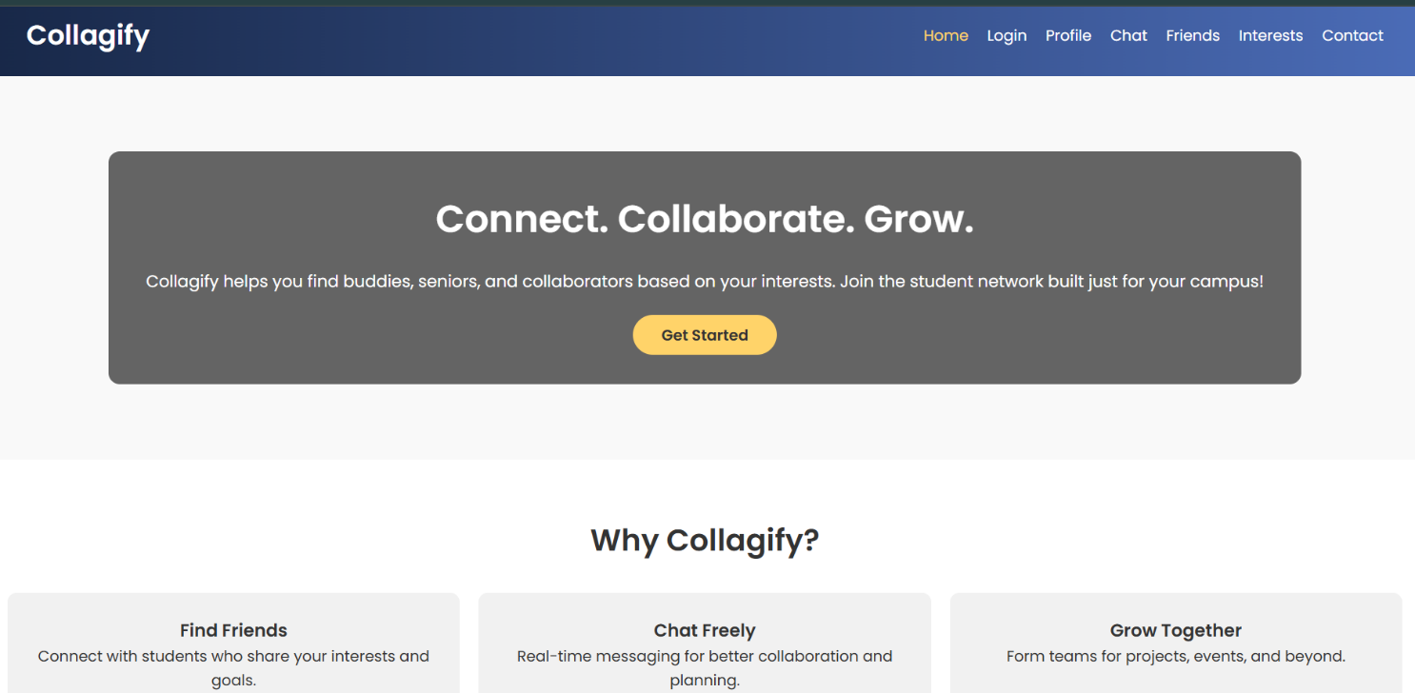

- **Sign Up/Login Page**: Allows users to authenticate securely using Firebase or Google OAuth.

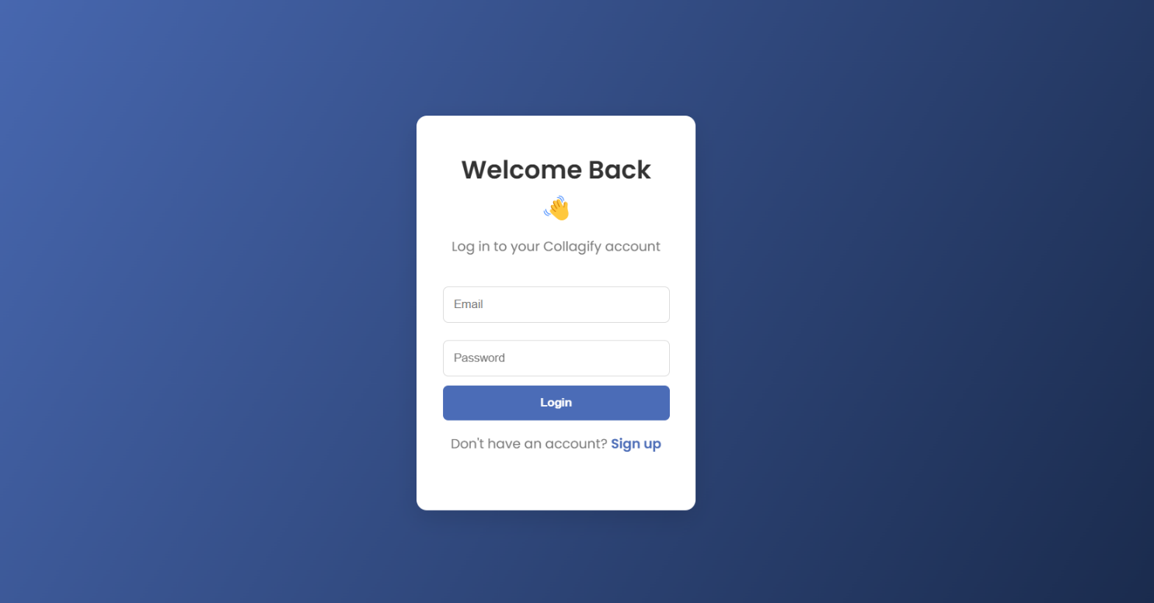

- **Dashboard**: Displays recommended buddies, upcoming events, and user activity.

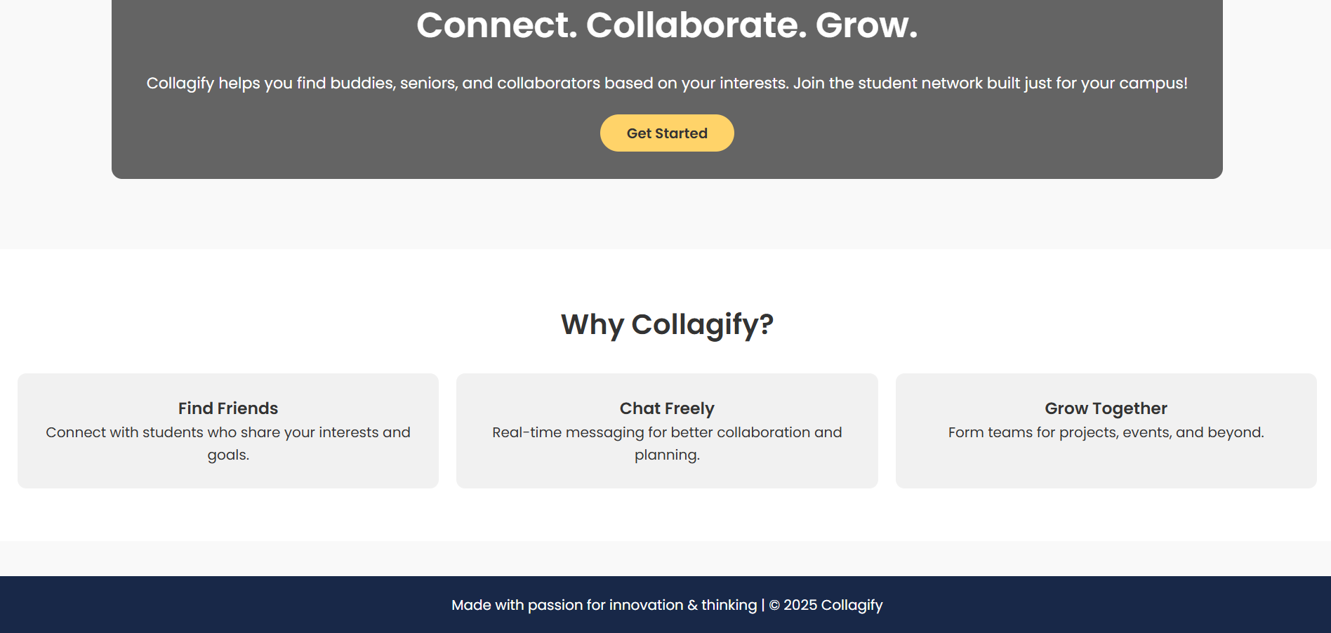

- **Profile Page**: Lets users manage personal info, interests, and skill tags.

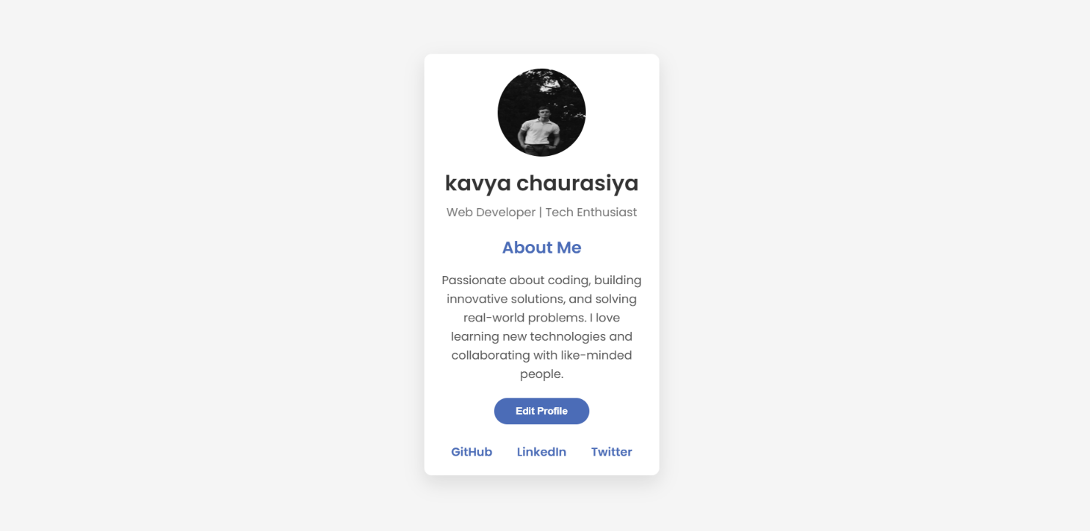

- **Chat Interface**: Enables users to communicate in real-time with matched peers.

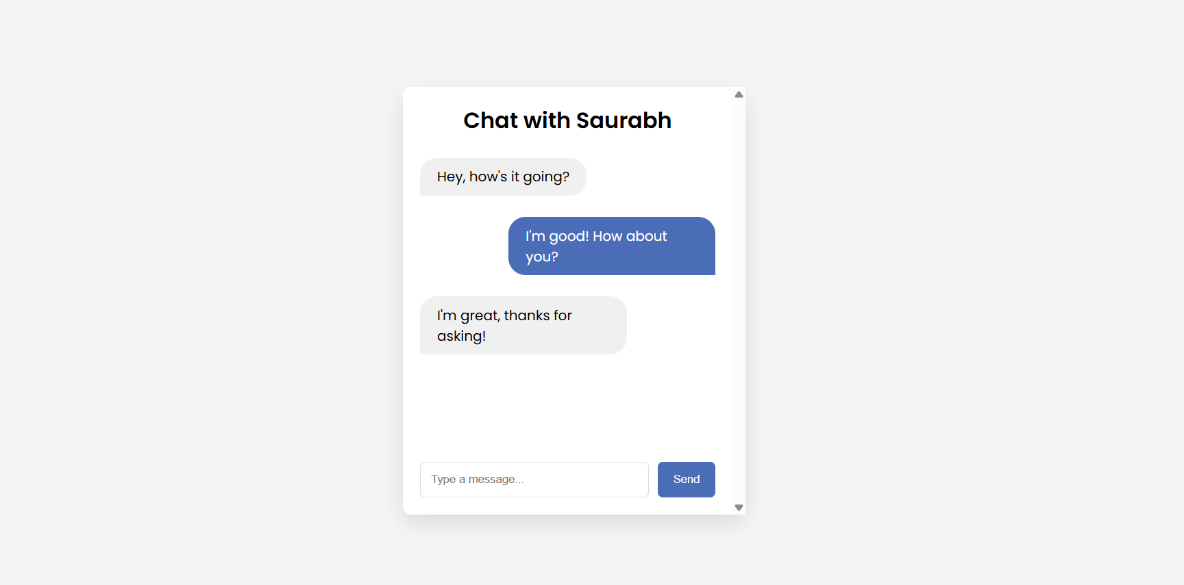

- **Friend request **: Simple show if the user is currently open to connections.

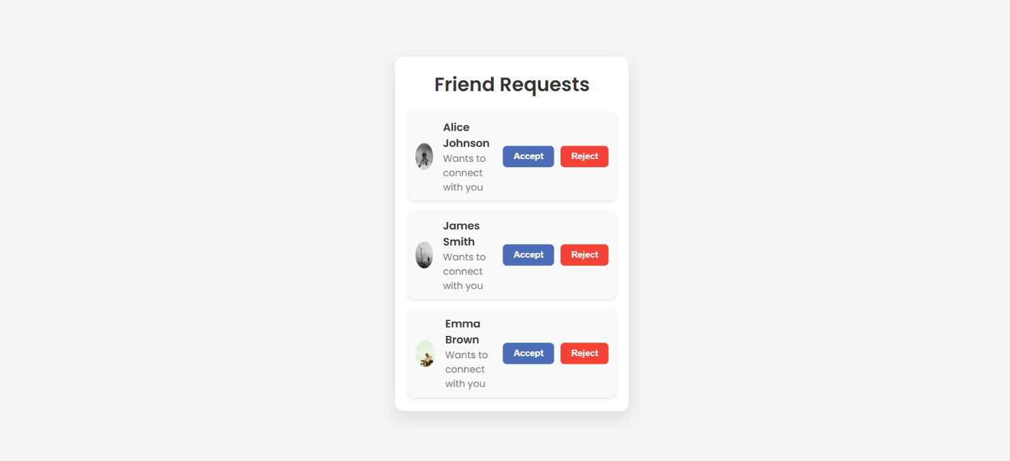

**5. LIMITATION AND FUTURE ENHANCEMENT**

**5.1 Limitations**

* The current version supports only basic profile matching and messaging features.
* AI recommendations are based on limited profile data; more advanced analytics are not yet integrated.
* No support for group chats or multi-user collaboration tools.
* The application is currently available only as a web platform (no mobile app).
* Notifications and availability tracking are still in early development.
* Privacy settings and data control options for users are minimal in the prototype.

**5.2 Future Enhancements**

* Integration of advanced AI algorithms to improve buddy recommendations.
* Implementation of a full-featured mobile app for Android and iOS.
* Development of group chat and study room features.
* Gamification of user profiles to increase engagement (e.g., badges, activity points).
* Personalized event and opportunity suggestions based on user interests.
* Enhanced user privacy controls, including custom visibility settings.
* Admin panel for colleges to manage users, post events, and monitor engagement.
* Integration with academic systems like LMS (Learning Management Systems) for deeper academic support.

| Date | Activity |
| --- | --- |
| 10/01/2025 | Group formation and introduction to Innovation and Design Thinking – II |
| 25/01/2025 | Identifying the main problem |
| 12/02/2025 | Planning the solution to implement the idea |
| 15/02/2025 | Roles & Responsibilities in the Group |
| 09/03/2025 | Patent & research study |
| 22/03/2025 | Tools and Techniques used |
| 10/04/2025 | Benefits, contribution & future scopes |
| 18/04/2025 | Completed all the canvases w |
| 24/04/2025 | Project submission and viva preparation |

1. **TIMELINE CHART**

Chapter 7: CONCLUSION

The *Collegify* project was designed and developed with the goal of solving a common and relevant problem faced by college students — the lack of a structured platform for finding compatible peers for academic and social collaboration. Throughout this project, we followed the principles of Innovation and Design Thinking to identify the problem, research possible solutions, and create a functional prototype.

The platform uses AI-powered suggestions and real-time features to help students connect based on their courses, skills, and interests. From a technical standpoint, it incorporates modern web technologies such as HTML, CSS, JavaScript, and Firebase for smooth performance and secure data handling.

By working on *Collegify*, we not only applied our technical knowledge but also improved our understanding of real-world problem solving, teamwork, and user-centric design. The feedback from potential users was positive, and the system shows strong potential for further development.

In the future, we plan to improve the platform with new features like group chats, mobile app versions, event notifications, and deeper integration with academic tools. We believe *Collegify* can significantly contribute to better student networking and enhance the overall college experience.

This project reflects our commitment to developing meaningful and innovative solutions that benefit both students and institutions.

Chapter 8: REFERENCES

1. U.S. Patent US7069308B2. *System, Method, and Apparatus for Connecting Users in an Online Computer System Based on Their Relationships within Social Networks*.
2. U.S. Patent US11438334B2. *Systems and Methods for Securing Social Media Platforms*.
3. Firebase Documentation. *Google Firebase*. <https://firebase.google.com/docs>
4. Netlify Documentation. *Netlify Platform for Deployment*. <https://docs.netlify.com>
5. MDN Web Docs. *HTML, CSS, and JavaScript Web Technologies*. <https://developer.mozilla.org>
6. GitHub Pages Documentation. *Hosting Projects with GitHub Pages*. <https://pages.github.com>